**Interrupt** is the method of creating a temporary halt during program execution and allows peripheral devices to access the microprocessor. The microprocessor responds to that interrupt with an **ISR** (Interrupt Service Routine), which is a short program to instruct the microprocessor on how to handle the interrupt.

The following image shows the types of interrupts we have in a 8086 microprocessor −

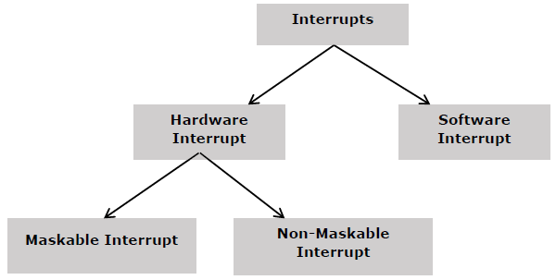

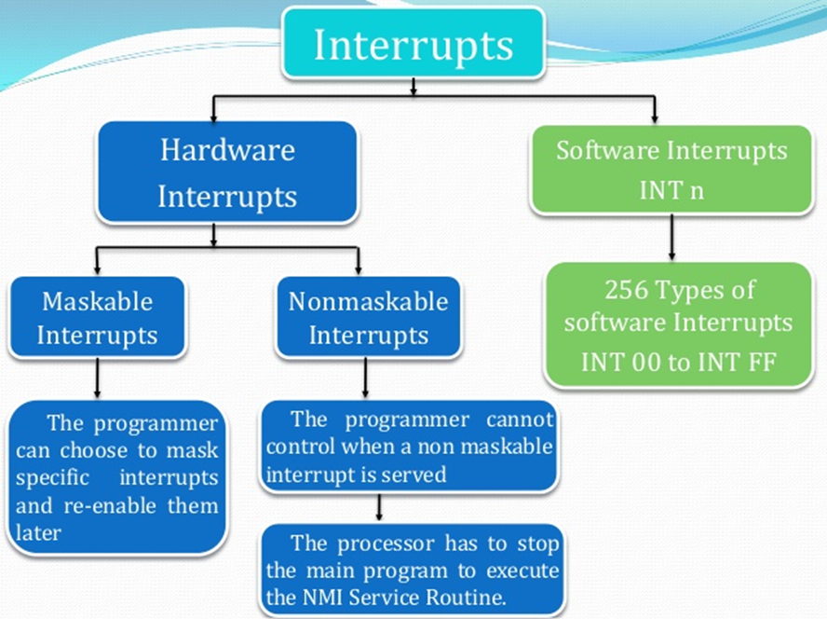

Hardware Interrupts

Hardware interrupt is caused by any peripheral device by sending a signal through a specified pin to the microprocessor.

The 8086 has two hardware interrupt pins, i.e. NMI and INTR. NMI is a non-maskable interrupt and INTR is a maskable interrupt having lower priority. One more interrupt pin associated is INTA called interrupt acknowledge.

NMI

It is a single non-maskable interrupt pin (NMI) having higher priority than the maskable interrupt request pin (INTR)and it is of type 2 interrupt.

When this interrupt is activated, these actions take place −

* Completes the current instruction that is in progress.
* Pushes the Flag register values on to the stack.
* Pushes the CS (code segment) value and IP (instruction pointer) value of the return address on to the stack.
* IP is loaded from the contents of the word location 00008H.
* CS is loaded from the contents of the next word location 0000AH.
* Interrupt flag and trap flag are reset to 0.

This interrupt **cannot** be disabled/masked – by any prog instructions.

As this input can’t be intentionally or accidentally disabled, external system must be taken care of.

Example:

We could have a **pressure sensor** on a large steam boiler – connected to the **NMI** input.

If the pressure goes above a preset limit, the sensor will send an interrupt signal to the 8086.

Type 2 interrupt-service procedure for this case might

* + turn off the fuel to the boiler
  + open a pressure-relief valve and
* sound an alarm!

INTR

The INTR is a maskable interrupt because the microprocessor will be interrupted only if interrupts are enabled using set interrupt flag instruction. It should not be enabled using clear interrupt Flag instruction.

The INTR interrupt is activated by an I/O port. If the interrupt is enabled and NMI is disabled, then the microprocessor first completes the current execution and sends ‘0’ on INTA.

These actions are taken by the microprocessor −

* First completes the current instruction.
* Activates INTA output and receives the interrupt type, say X.
* Flag register value, CS value of the return address and IP value of the return address are pushed on to the stack.
* IP value is loaded from the contents of word location X × 4
* CS is loaded from the contents of the next word location.
* Interrupt flag and trap flag is reset to 0

Software Interrupts

Some instructions are inserted at the desired position into the program to create interrupts. These interrupt instructions can be used to test the working of various interrupt handlers. It includes −

INT- Interrupt instruction with type number

There are 256 interrupt types under this group.

Its execution includes the following steps −

* Flag register value is pushed on to the stack.
* CS value of the return address and IP value of the return address are pushed on to the stack.
* IP is loaded from the contents of the word location ‘type number’ × 4
* CS is loaded from the contents of the next word location.
* Interrupt Flag and Trap Flag are reset to 0

The starting address for type0 interrupt is 000000H, for type1 interrupt is 00004H similarly for type2 is 00008H and ……so on. The first five pointers are dedicated interrupt pointers. i.e. −

* **TYPE 0** interrupt represents division by zero situation.
* **TYPE 1** interrupt represents single-step execution during the debugging of a program.
* **TYPE 2** interrupt represents non-maskable NMI interrupt.
* **TYPE 3** interrupt represents break-point interrupt.
* **TYPE 4** interrupt represents overflow interrupt.

The interrupts from Type 5 to Type 31 are reserved for other advanced microprocessors, and interrupts from 32 to Type 255 are available to user for hardware and software interrupts.

INT 3-Break Point Interrupt Instruction

It is a 1-byte instruction having op-code is CCH. These instructions are inserted into the program so that when the processor reaches there, then it stops the normal execution of program and follows the break-point procedure.

Its execution includes the following steps −

* Flag register value is pushed on to the stack.
* CS value of the return address and IP value of the return address are pushed on to the stack.
* IP is loaded from the contents of the word location 3×4 = 0000CH
* CS is loaded from the contents of the next word location.
* Interrupt Flag and Trap Flag are reset to 0

INTO - Interrupt on overflow instruction

It is a 1-byte instruction and their mnemonic **INTO**. The op-code for this instruction is CEH. As the name suggests it is a conditional interrupt instruction, i.e. it is active only when the overflow flag is set to 1 and branches to the interrupt handler whose interrupt type number is 4. If the overflow flag is reset then, the execution continues to the next instruction.

Its execution includes the following steps −

* Flag register values are pushed on to the stack.
* CS value of the return address and IP value of the return address are pushed on to the stack.
* IP is loaded from the contents of word location 4×4 = 00010H
* CS is loaded from the contents of the next word location.
* Interrupt flag and Trap flag are reset to 0

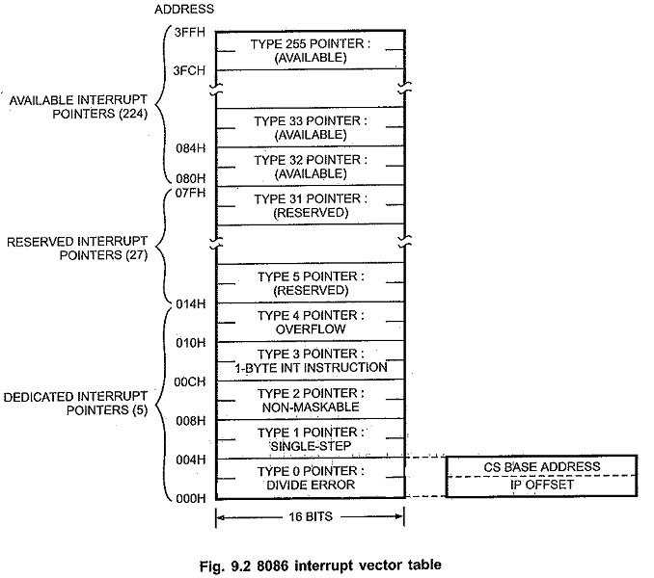

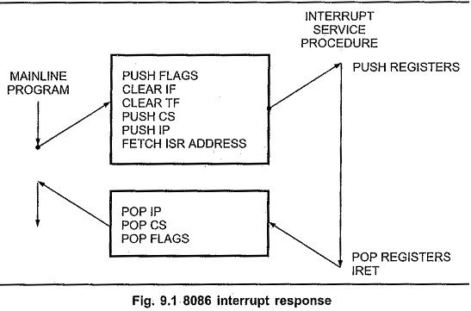

**Hardware interrupt Applications:**

Used to handle external Hardware peripherals, such as keyboards, mouse, hard disks, floppy disks, DVD drivers and printers

* Timer Application
* LED Application
* Priority Interrupt Controller

**Software Interrupt Applications:**

* Is to call basic input output system, or BIOS procedure
* Reading a character from the keyboard
* Writing some character to the CRT or reading some information from a disk